Traces of The Universe: Role of Cosmogenous Sediment
Imagine you are somewhere in world's ocean looking in the sky wondering it's vastness. You can somehow imagine this vastness, but when it comes to the universe and the outer space, your calculations get muddled! You wonder how extensive it is and sometime it's beyond your imagination! Now thousands of questions signals you, what else is there in space besides planets and stars? Is it possible to found anything from there around me? Do the things even exist to be found? Ok, the answer is, Yes! You can find materials from outer space around you and it can be the world ocean you are in right now. Let's dive deeper into it!

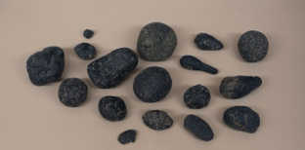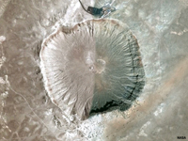
fig: A Cosmogenous Sediment fig: Meteor Crater (Diablo Canyon site) near

“Sediment” the initiator - Sediment are some particle of rock, mineral or organic material that accumulate in a place carried by wind, water, ice etc. There are four types of sediments, they are: Lithogenous, Hydrogenous, Biogenous and Cosmogenous. Now all your questions earlier stuck here in “Cosmogenous Sediment”.

Cosmogenous sediment refers to the sediment that originates from the outer space and settles down on Earth surface sometimes found in the world ocean or sometimes with the other sediment. It is the only sediment that originates from the extraterrestrial source. It includes debris from outer space, meteorites, and other cosmic particles. This Sediment Mainly comes in two forms, these are: Microscopic spherules and Lager meteor debris.
Spherules are composed of mainly silica, iron and nickel. Microscopic spherules are formed by the rapid cooling of incoming cosmic particle in the earth. Eventually they settle back down to earth surface.
The large meteor debris forms by the fragmentation of celestial bodies, asteroids etc. One interesting form of debris form is "Tektites", it is small droplet of glass that is ejected from the collision of meteorites in a liquid form then solidifies as it cools down while coming to earth.

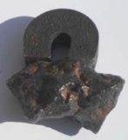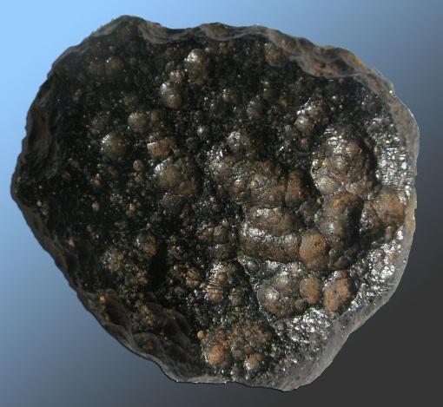
fig: Iron-nickel meteorite fig: A Tektite

A continuous cosmic dust enters the earth, much of these burns up and dissolves before reaching the ocean floor and some settle directly in ocean. It is the rarest sediment to be found. About 90 % of incoming cosmic particles vaporize entering the earth atmosphere. It is estimated that 5 to 300 tons of space dust land on earth every day, 10 kilogram (22pound) per second!
There is a term called space weathering- an interaction of solar wind and cosmic radiation with extraterrestrial materials in space. This sediment give an insights in space weathering also these are very important in the sense of the history of space, space current condition, solar system along with whole universe as well as their impacts on Earth.
This sediment helps to understand the processes that occur in the space. In fact, past space condition or formation of the meteorites can also be found by proper analyzing. Isn’t this types of sediment is very fascinating!

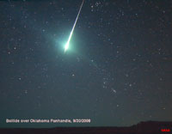
Fig: A meteor fireball (a bolide) disintegrates in the night sky over Oklahoma

Though there are some challenges studying Cosmogenous sediment. Firstly, it is quite difficult to collect sample of Cosmogenous sediment from the space. Secondly, there are lacks of specialized equipment to analyze the sediment. Thirdly, slow concentration makes it harder to detect. These sediments are found in various locations in the ocean, areas like the deep ocean floor near mid-ocean ridges and ocean basins having higher concentrations.
As this type of sediment is very rare and the concentration is low but it can gives us very important information about the outer space and by analyzing this sediment properly we can know about many unknown secret of universe!

References:

https://rwu.pressbooks.pub/webboceanography/chapter/12-5-cosmogenous-sediments/#:~:text=Cosmogenous%20sediment%20is%20derived%20from,upon%20returning%20to%20the%20surface.
https://studyhub.net.in/oceanography/what-are-the-characteristics-of-cosmogenous-sediment/#:~:text=by%20StudyHUB,drawn%20by%20Earth's%20gravitational%20pull
https://geo.libretexts.org/Bookshelves/Oceanography/Oceanography_101_(Miracosta)/06%3A_Marine_Sediments/6.02%3A_Cosmogenous_Sediments

